1.4.12 Item Master Copy
In this function we can create a new article by copying basic data from already existing item .

Copy Item Number: put existing article from the same range, in this case from PG 1310
To: put existing article and change dimension
+ YES
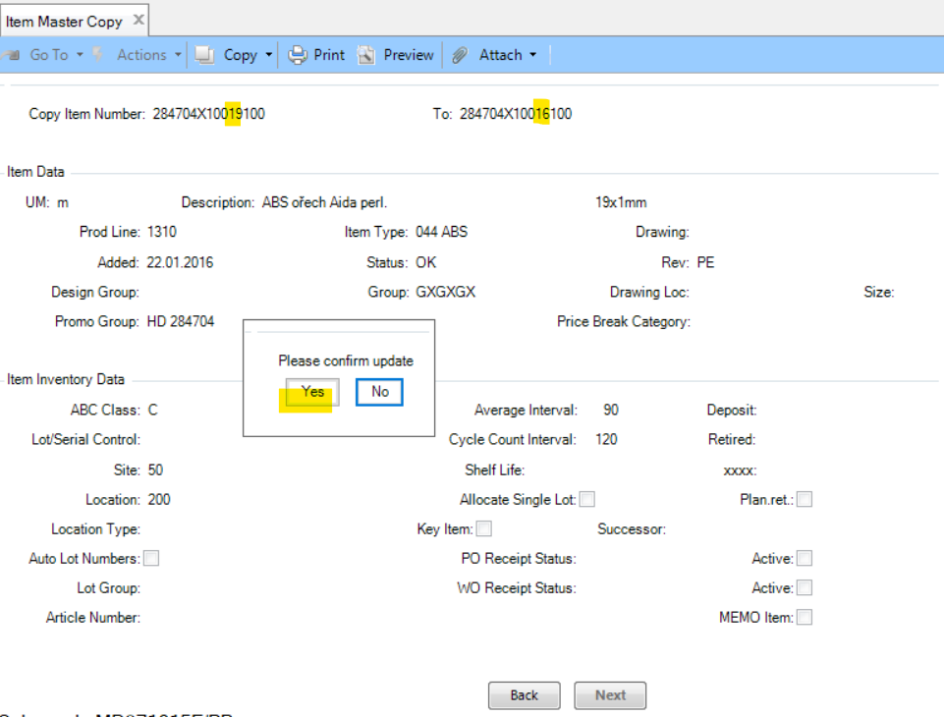

See next page.

UM: unit is copied (but still watch out for the correct unit)
Description: overwrite for correct dimension
Prod Line: product group (PG) is copied from original article, but always check and set PG correctly according to the nature of the article (PG 1310 slitted, PG 1510 extruded, egc.). Kindly note that PG 1010 (collection) enteres only HRX CZ!
Promo Group: is copied (if not, just maintain accordingly HD (wooden) or HU (uni colours + melamines) + name of decor or)
Item Type: is copied from original item (can be also blank)
Status: set OK (otherwise you cannot make a goods reciept on your side later, but be aware of maintain costs at the end of this function = OK also means that the price is set up)
Rev or Revision: means a surface (it is copied, e.g. PE = pearl)

+ Next
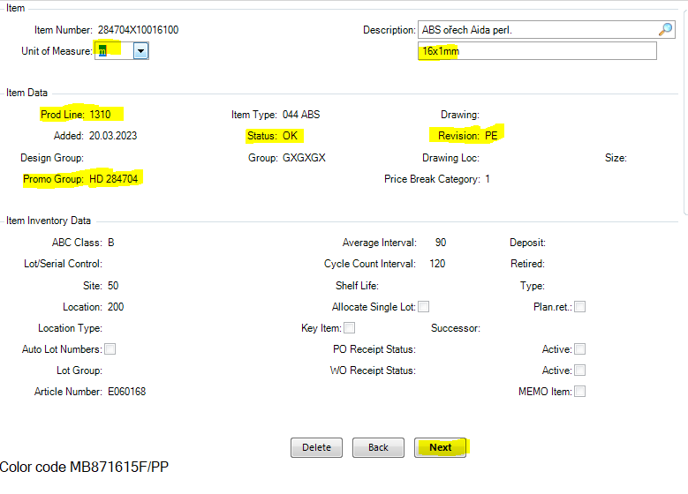

Material - here you put your purchase price from HRX HQ (branches call this as costs).
If you know it, you can put it right away.
If unsure, enter 0,00000. You must then enter the amount here later based on the invoice from HRX HQ.
Kindly note that each article with status OK needs to have the purchase price/costs to be maintaned here.
+ Next
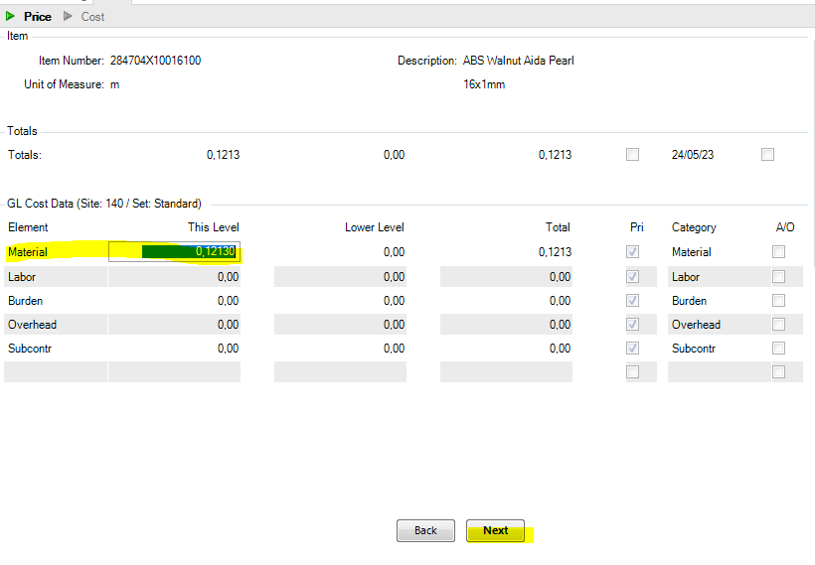

After another few Next you are in this screen = YES.
When your branch transfers the article to another domains, HRX CZ will see it in PG 5050. Then HRX CZ (production assistant) enters all other data and calculation of our costs and make new replication to all domains including yours.

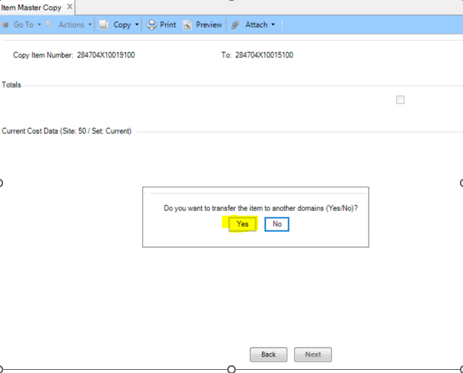

And that´s it.

Now only translation of article decription is need to be done in function 36.11.12.23 Item Translations Maintenance.

